

Database Systems and Data Driven Applications

(IT3031)

3rd Year, 1st Semester

**Assignment 1**

Submitted to

Sri Lanka Institute of Information Technology

**Bachelor of Science Special Honors Degree in Data Science**

# IT17167710

**D.M.J. Prathapa**

1)

Report – 1

**Coronavirus COVID-19 Summary of Total Cases (worldwide Overall)**

This report contains about the total number of cases all around the world.

Covid-19 Total Cases = total cumulative count (304,524). This figure therefore includes recovered, deaths and currently infected patients.

According to my analysis

12,973 people have died, 91,499 recovered, and 200,052 people are currently infected so far from the coronavirus COVID-19 outbreak as of 22-MAR- 2020

Report -2

**Coronavirus COVID-19 Mortality Rate /case fatality rate Report - (country and state wise)**

This report contains countries and states and the number of death cases and the rate of Mortality which means this report represents number of death cases and the percentage (%) of death cases who eventually die from a **COVID-19** disease.)

The Mortality rate, which is known as **case fatality rate** can be calculated by dividing current total deaths from current confirmed cases, we can get the proportion of Mortality and multiply by hundred we can get the **rate (%) of Mortality.**

Report -3

**Coronavirus COVID-19 Recovered / Discharged- (country and state wise)**

This report contains countries and states and the number of recovery cases (Discharged patients) and the **rate of recovery**.

by dividing **recovery** cases from the total of confirmed cases, we can get the **proportion of recovery cases** and multiply by hundred we can get the **rate (%) of recovery cases**

Report -4

**Coronavirus COVID-19 CLOSED Cases - (country and state wise)**

this report mainly considers about COVID-19 Cases which had an outcome, which means total of Recovered (Discharged) and death cases.

By adding recoveries and deaths count, we get **" CLOSED Cases count.** And adding both **rate of recovery** and **Mortality Rate** together or by dividing **CLOSED Cases count** from the total of confirmed cases**.** we get the **rate (%) of CLOSED Cases**

Report -5

**Coronavirus COVID-19 Active Cases - (country and state wise)**

This report represents countries, states and the number of Currently Infected Patients and the percentage (%) of Currently Infected Patients which are affected by **COVID-19** disease.)

By reducing recoveries and deaths count from confirmed total cases, we get "currently infected cases" or "active cases”. And by dividing active cases from the total of confirmed cases, we can get the **proportion of active cases** and multiply by hundred we can get the **rate (%) of active cases**

Report-6

**Coronavirus COVID-19 Cases - (Coronavirus Cases in China vs Outside of China)**

1. **(Coronavirus Cases in China)**

This report represents the total number of deaths, Active cases, recovery cases and Confirmed cases of coved 19 in china on the date of 21th March 2020.

1. **(Coronavirus Cases outside of China)**

This report represents Total Coronavirus confirmed Cases, Active Cases, Deaths cases, recovery cases and closed cases in outside of China

Report-7

**Coronavirus COVID-19 Cases – Comparisons**

This report contains about full detailed report of the countries which exceeded 10000 patients of **COVID-19**. And each state of them where death toll is reported more than the recovery toll on 21th March,2020

2)

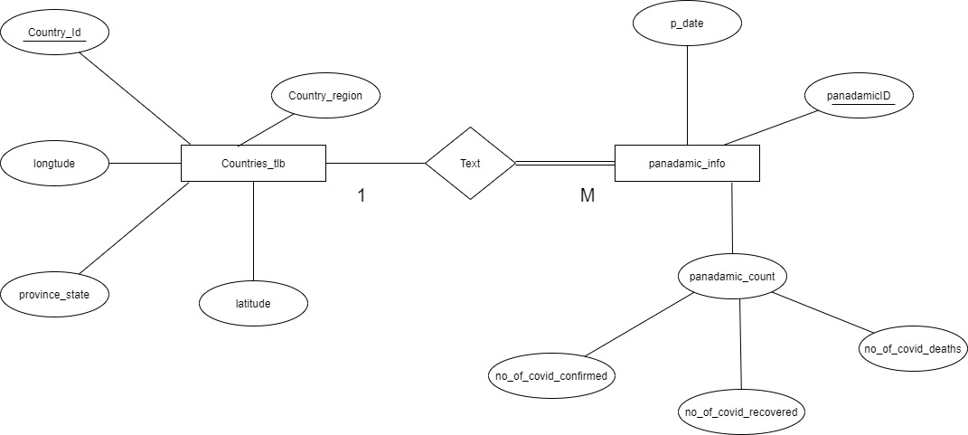

3)

Object relation model

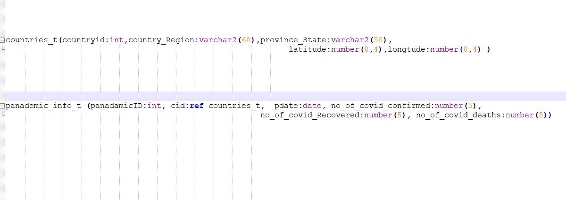

Object diagram

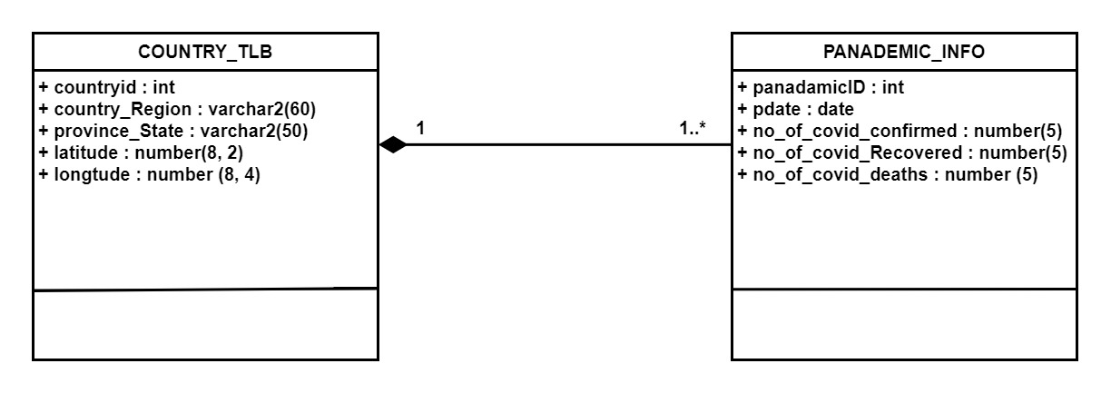

**4)**

Types

* To create and describe the table **countries_tlb** that contains the columns countryid, country_Region, province_State, latitude and longtude, enter.

**CREATE** **TYPE** countries_t **AS** **OBJECT** **(**

countryid int**,**

country_Region varchar2**(**60**),**

province_State varchar2**(**50**),**

latitude number**(**8**,**4**),**

longtude number**(**8**,**4**)**

**)**

**/**

* To create and describe the table **panademic_info** that contains the columns cid, pdate, province_State ,no_of_covid_confirmed , no_of_covid_Recovered and l no_of_covid_deaths.

**create** **TYPE** panademic_info_t **as** **object(**

panadamicID int,

cid **ref** countries_t**,**

pdate date**,**

no_of_covid_confirmed number**(**5**),**

no_of_covid_Recovered number**(**5**),**

no_of_covid_deaths number**(**5**)**

**)**

**/**

-tables-

**create** **table** countries_tlb **of** countries_t**(**

countryid **primary** **key**

**)**

**/**

**create** **table** panademic_info **of** panademic_info_t**(**

panadamicID **primary** **key**

**)**

**/**

**5)**

* Create a folder called **dsda_it17167710_mid** and add given 3 CSV files into that.
* Then I grant the read write permission to the user by executing following commands as SYSTEM user. 'c:\dsda_it17167710_mid\' must be a physical path on the disk.

conn **/** **as** sysdba

**CREATE** **OR** **REPLACE** DIRECTORY MY_DIRECTORY **AS** 'c:\dsda_it17167710_mid\';

**GRANT READ, WRITE** ON DIRECTORY MY_DIRECTORY TO janith_dsds;

**GRANT EXECUTE** ON SYS.utl_file TO janith_dsds;

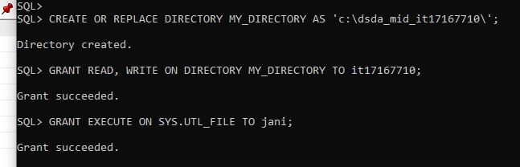

* Then I renamed CSV files as covid_Confirmed, covid_Deaths, covid_Recovered and replace all empty fields in the Province/state column by using value NULL.

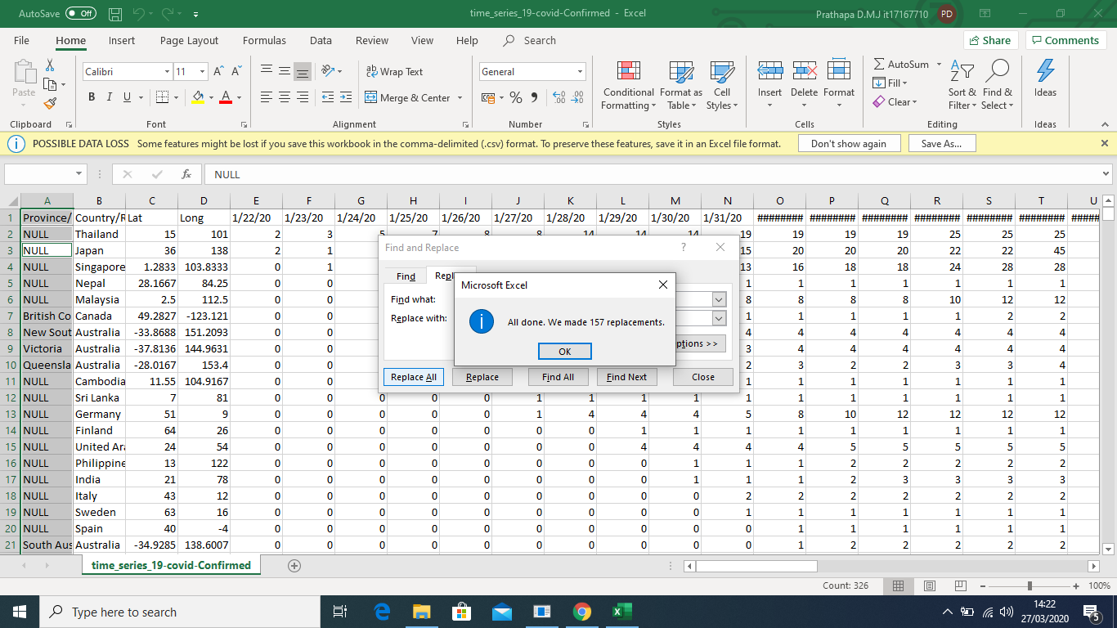

* To Load " covid_Confirmed.CSV, covid_Deaths.CSV, covid_Recovered.CSV " file into Oracle Tables I have created all the tables and

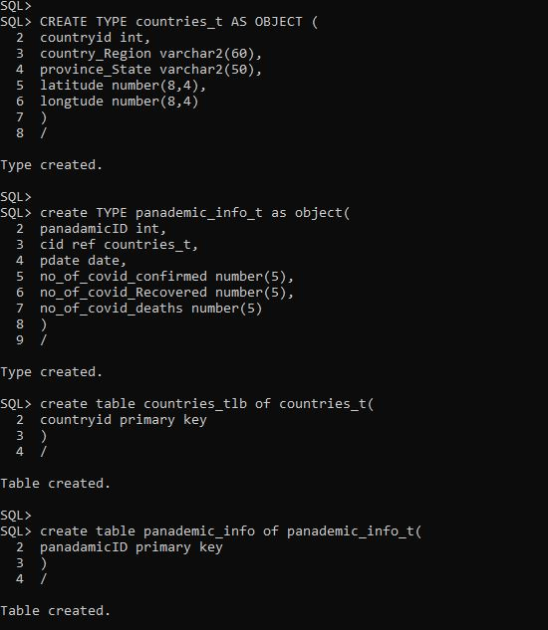

* Once the tables and types are created, Then I executed the following pl/sql code block to get the all dates into a separate CSV file called **covid_dates.CSV**.

Read the **covid_Confirmed.CSV file**

**DECLARE**

F UTL_FILE**.**FILE_TYPE**;**

WRITE_FILE UTL_FILE**.**FILE_TYPE**;**

covid_LINE VARCHAR2 **(**1000**);**

covid_date VARCHAR2**(**50**);**

i number**(**5**);**

**BEGIN**

F **:=** UTL_FILE**.**FOPEN**(**'MY_DIRECTORY'**,**'c:\dsda_mid_it17167710\covid_Confirmed.CSV'**,**'R'**);**

WRITE_FILE **:=**UTL_FILE**.**FOPEN**(**'MY_DIRECTORY'**,**'c:\dsda_mid_it17167710\covid_dates.CSV'**,**'W'**);**

**IF** UTL_FILE**.**IS_OPEN**(**F**)** **THEN**

**LOOP**

**BEGIN**

UTL_FILE**.**GET_LINE**(**F**,** covid_LINE**,** 1000**);**

**IF** covid_LINE **IS** **NULL** **THEN**

**EXIT;**

**END** **IF;**

i **:=**5**;**

**LOOP**

**BEGIN**

covid_date **:=** **replace(**REGEXP_SUBSTR**(**covid_LINE**,** '("([^"]*)")|[^,]+'**,** 1**,** i**),**'"'**,**''**);**

UTL_FILE**.**PUT_LINE**(**WRITE_FILE**,**covid_date**);**

**COMMIT;**

i**:=**i+1**;**

**IF** covid_date **IS** **NULL** **THEN**

**EXIT;**

**END** **IF;**

**END;**

**END** **LOOP;**

**EXIT;**

Write dates in to **covid_dates.CSV** file

* After the execution of above procedure, a file (**covid_dates.CSV**) would have been created at **'c:\dsda_it17167710_mid\**’location.

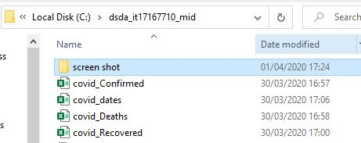

* to create an incrementing numeric key, I create a sequence.

**create** **SEQUENCE** seq1

**start** **with** 1

**increment** **by** 1**;**

* then I define a trigger called **covid_countries_trigger** that automatically populates the primary key value using the sequence **seq1**

**CREATE** **OR** **REPLACE** **TRIGGER** covid_countries_trigger

**BEFORE** **INSERT**

**ON** countries_tlb

**REFERENCING** **NEW** **AS** **NEW**

**FOR** **EACH** **ROW**

**BEGIN**

**SELECT** seq1**.nextval** **INTO** **:NEW.**countryid **FROM** dual**;**

**END;**

**/**

Then I do the same thing for the **panademic_info table.**

**create** **SEQUENCE** seq2

**start** **with** 1

**increment** **by** 1**;**

* then I executed the bellow a trigger called **covid_ panadamic_trigger** that automatically populates the primary key value using the sequence **seq2**

**CREATE** **OR** **REPLACE** **TRIGGER** covid_ panadamic_trigger

**BEFORE** **INSERT**

**ON** panademic_info

**REFERENCING** **NEW** **AS** **NEW**

**FOR** **EACH** **ROW**

**BEGIN**

**SELECT** seq1**.nextval** **INTO** **:NEW.**panadamicID **FROM** dual**;**

**END;**

**/**

* Then I change the date format by using bellow session because in the previous attempt I got an error called ORA-01843: "not a valid month".

**ALTER** **SESSION** **SET** NLS_DATE_FORMAT **=** 'MM/DD/YYYY'**;**

After that I create one more procedure to, load CSV data to the both tables. By executing the following pl/sql block date load the CSV file into the Oracle table.

**DECLARE**

ConfirmedCSV UTL_FILE**.**FILE_TYPE**;**

DeathsCSV UTL_FILE**.**FILE_TYPE**;**

RecoveredCSV UTL_FILE**.**FILE_TYPE**;**

WIRTE_FILE UTL_FILE**.**FILE_TYPE**;**

covid_LINE_C VARCHAR2 **(**2000**);**

covid_LINE_D VARCHAR2 **(**2000**);**

covid_LINE_R VARCHAR2 **(**2000**);**

covid_LINE2 VARCHAR2 **(**2000**);**

covid_date VARCHAR2**(**50**);**

covid_Confirmed NUMBER**(**7**);**

covid_Deaths NUMBER**(**7**);**

covid_Recoverd NUMBER**(**7**);**

covid_state VARCHAR2**(**50**);**

covid_region VARCHAR2**(**50**);**

covid_lat NUMBER**(**8**,**4**);**

covid_long NUMBER**(**8**,**4**);**

i number**(**5**);**

**row** number**(**5**);**

**BEGIN**

ConfirmedCSV **:=** UTL_FILE**.**FOPEN **(**'MY_DIRECTORY'**,**'c:\dsda_mid_it17167710\covid_Confirmed.CSV'**,** 'R'**);**

DeathsCSV **:=** UTL_FILE**.**FOPEN **(**'MY_DIRECTORY'**,**'c:\dsda_mid_it17167710\covid_Deaths.CSV'**,** 'R'**);**

RecoveredCSV **:=** UTL_FILE**.**FOPEN **(**'MY_DIRECTORY'**,**'c:\dsda_mid_it17167710\covid_Recovered.CSV'**,** 'R'**);**

i**:=**0**;**

**row:=**0**;**

**IF** UTL_FILE**.**IS_OPEN**(**ConfirmedCSV**)** **AND** UTL_FILE**.**IS_OPEN**(**DeathsCSV**)** **AND** UTL_FILE**.**IS_OPEN**(**RecoveredCSV**)** **THEN**

**LOOP**

**BEGIN**

i**:=**i+1**;**

UTL_FILE**.**GET_LINE**(**ConfirmedCSV**,** covid_LINE_C**,** 2000**);**

UTL_FILE**.**GET_LINE**(**DeathsCSV**,** covid_LINE_D**,** 2000**);**

UTL_FILE**.**GET_LINE**(**RecoveredCSV**,** covid_LINE_R**,** 2000**);**

**IF** i **=**1 **THEN**

**CONTINUE;**

**END** **IF;**

**IF** covid_LINE_C **IS** **NULL** **THEN**

**EXIT;**

**END** **IF;**

i **:=**5**;**

covid_state **:=** **replace(**REGEXP_SUBSTR**(**covid_LINE_C**,** '("([^"]*)")|[^,]+'**,** 1**,** 1**),**'"'**,**''**);**

covid_region **:=** REGEXP_SUBSTR**(**covid_LINE_C**,** '("([^"]*)")|[^,]+'**,** 1**,** 2**);**

covid_lat **:=** REGEXP_SUBSTR**(**covid_LINE_C**,** '("([^"]*)")|[^,]+'**,** 1**,** 3**);**

covid_long **:=** REGEXP_SUBSTR**(**covid_LINE_C**,** '("([^"]*)")|[^,]+'**,** 1**,** 4**);**

**INSERT** **INTO** countries_tlb **VALUES(**0**,**covid_region**,**covid_state**,**covid_lat**,**covid_long**);**

**COMMIT;**

**row** **:=row**+1**;**

WIRTE_FILE **:=** UTL_FILE**.**FOPEN **(**'MY_DIRECTORY'**,**'c:\dsda_mid_it17167710\covid_dates.CSV'**,** 'R'**,**2000**);**

**IF** UTL_FILE**.**IS_OPEN**(**WIRTE_FILE**)** **THEN**

**LOOP**

**BEGIN**

UTL_FILE**.**GET_LINE**(**WIRTE_FILE**,** covid_LINE2**,** 100**);**

**IF** covid_LINE2 **IS** **NULL** **THEN**

UTL_FILE**.**FCLOSE**(**WIRTE_FILE**);**

**EXIT;**

**END** **IF;**

covid_date **:=** REGEXP_SUBSTR**(**covid_LINE2**,** '("([^"]*)")|[^,]+'**,** 1**,** 1**);**

covid_Confirmed **:=** REGEXP_SUBSTR**(**covid_LINE_C**,** '("([^"]*)")|[^,]+'**,** 1**,** i**);**

covid_Deaths **:=** REGEXP_SUBSTR**(**covid_LINE_D**,** '("([^"]*)")|[^,]+'**,** 1**,** i**);**

covid_Recoverd **:=** REGEXP_SUBSTR**(**covid_LINE_R**,** '("([^"]*)")|[^,]+'**,** 1**,** i**);**

**INSERT** **INTO** panademic_info **values(0,(select** **ref(**c**)** **from** countries_tlb c **where** c**.**countryid**=row)** **,** covid_date **,** covid_Confirmed**,**covid_Recoverd**,**covid_Deaths**);**

**COMMIT;**

i**:=**i+1**;**

**END;**

**END** **LOOP;**

**END** **IF;**

**EXCEPTION**

**WHEN** NO_DATA_FOUND **THEN**

**EXIT;**

**END;**

insert query for load data to  **countries_tlb**

**END** **LOOP;**

**END** **IF;**

**IF** UTL_FILE**.**is_open**(**WIRTE_FILE**)** **THEN**

UTL_FILE**.**fclose**(**WIRTE_FILE**);**

**END** **IF;**

UTL_FILE**.**FCLOSE**(**ConfirmedCSV**);**

UTL_FILE**.**FCLOSE**(**DeathsCSV**);**

UTL_FILE**.**FCLOSE**(**RecoveredCSV**);**

**END;**

**/**

insert query for load data to  **panademic_info**

Data of "**countries_tlb**" and “**panademic_info**” can be determined as following

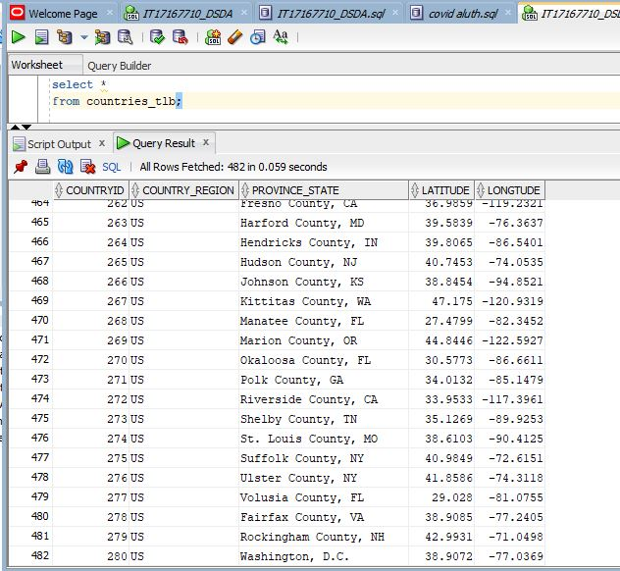

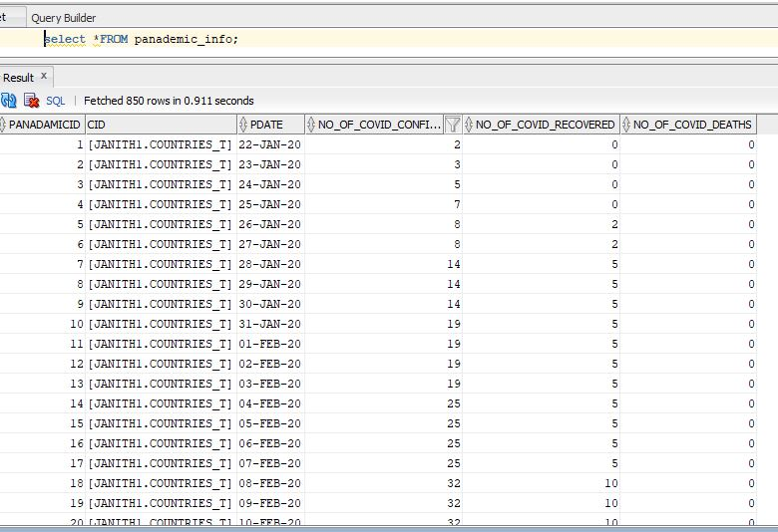

**6) Member methods**

* **MEMBER FUNCTION 1: calculate the number of Closed Cases**

**number of Closed Cases** = **Recovered count +** deaths count

* **MEMBER FUNCTION 2: calculate the number of Active cases**

**number of Active cases** = **Confirmed patients- Recovered patients- Died patients**

* **MEMBER FUNCTION 3: calculate the Mortality Rate**

**Mortality Rate (**The case fatality rate) = (deaths count **/** **Confirmed count)*100**

* **MEMBER FUNCTION 4: calculate the Active cases Rate**

**Active cases Rate = (number of Active Cases /** **Confirmed count) *100**

* **MEMBER FUNCTION 5: calculate the Recovery cases Rate**

**Recovery cases Rate = (number of Recovered Cases /** **Confirmed count) *100**

**ALTER** **TYPE** panademic_info_t

**ADD** MEMBER **FUNCTION** numberOf_CLOSED_CASES

**RETURN** NUMBER **CASCADE;**

**ALTER** **TYPE** panademic_info_t

**ADD** MEMBER **FUNCTION** numberOf_Active_Cases

**RETURN** NUMBER **CASCADE;**

**ALTER** **TYPE** panademic_info_t

**ADD** MEMBER **FUNCTION** covid_mortality_Rate

**RETURN** FLOAT **CASCADE;**

**ALTER** **TYPE** panademic_info_t

**ADD** MEMBER **FUNCTION** Active_Cases_Rate

**RETURN** FLOAT **CASCADE;**

**ALTER** **TYPE** panademic_info_t

**ADD** MEMBER **FUNCTION** covid_recover_Rate

**RETURN** FLOAT **CASCADE;**

**CREATE** **OR** **REPLACE** **TYPE** **BODY** panademic_info_t

**AS** MEMBER **FUNCTION**

numberOf_CLOSED_CASES

**RETURN** NUMBER **IS**

**BEGIN**

**RETURN** SELF**.**no_of_covid_Recovered **+** SELF**.**no_of_covid_deaths;

**END** numberOf_CLOSED_CASES**;**

MEMBER **FUNCTION**

numberOf_Active_Cases

**RETURN** NUMBER **IS**

**BEGIN**

**RETURN** SELF**.**no_of_covid_confirmed **-**SELF**.**no_of_covid_Recovered **-**SELF**.**no_of_covid_deaths **;**

**END** numberOf_Active_Cases **;**

MEMBER **FUNCTION** covid_mortality_Rate

**RETURN** FLOAT **IS**

confirmed NUMBER**;**

**BEGIN**

confirmed **:=**1**;**

**IF** self**.**no_of_covid_confirmed **>**0 **THEN**

confirmed **:=**self**.**no_of_covid_confirmed**;**

**END** **IF;**

**RETURN** **(**self**.**no_of_covid_deaths **/**confirmed**)\***100**;**

**END** covid_mortality_Rate**;**

MEMBER **FUNCTION** Active_Cases_Rate

**RETURN** FLOAT **IS**

confirmed NUMBER**;**

x NUMBER**;**

**BEGIN**

confirmed **:=**1**;**

**IF** self**.**no_of_covid_confirmed **>**0 **THEN**

confirmed **:=**self**.**no_of_covid_confirmed**;**

**END** **IF;**

x**:=** SELF**.**no_of_covid_confirmed **-**SELF**.**no_of_covid_Recovered **-**SELF**.**no_of_covid_deaths **;**

**RETURN** **(**x **/**confirmed**)\***100**;**

**END** Active_Cases_Rate**;**

MEMBER **FUNCTION** covid_recover_Rate

**RETURN** FLOAT **IS**

confirmed NUMBER**;**

**BEGIN**

confirmed **:=**1**;**

**IF** self**.**no_of_covid_confirmed **>**0 **THEN**

confirmed **:=**self**.**no_of_covid_confirmed**;**

**END** **IF;**

**RETURN** **(**self**.**no_of_covid_Recovered **/**confirmed**)\***100**;**

**END** covid_recover_Rate**;**

**END;**

**7) OR-SQL statement to produce 5 reports**

1. **Coronavirus COVID-19 Summary of Total Cases (worldwide Overall)**

**SELECT** **SUM(**p**.**no_of_covid_confirmed**)AS** Total_confirmed**,**

**SUM(**p**.**no_of_covid_deaths**)AS** Total_deaths**,**

**SUM(**p**.**no_of_covid_recovered**)** **AS** Total_recovered**,**

**SUM(**p**.**numberOf_Active_Cases**())AS** Total_Active_cases**,**

**SUM(**p**.**numberOf_CLOSED_CASES**())AS** Total_Closed_Cases**,**

p**.**pdate **AS** Till_21_MAR_2020

**FROM**

panademic_info p

**WHERE**

p**.**pdate**=**'21-MAR-2020' **AND** p**.**no_of_covid_confirmed**>**0

**GROUP**

**by** p**.**pdate**;**

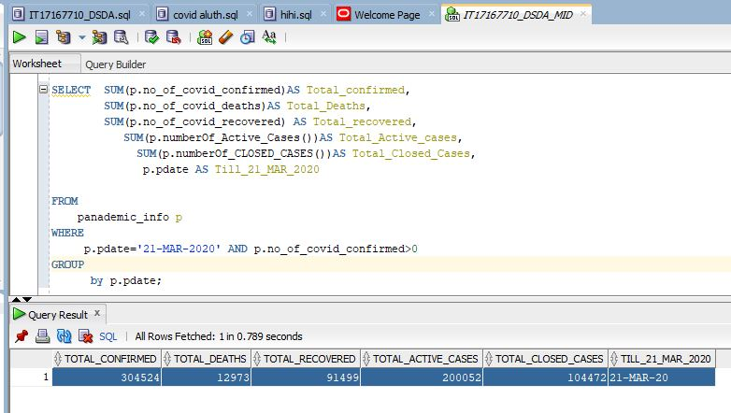

According to this report 12,973 people have died, 91,499 recovered, and 200,052 people are currently infected so far from the coronavirus COVID-19 outbreak as of 22-MAR- 2020

**Number of Closed Cases = Recovered count + deaths count**

91,499 + 12,973

----------------

104,472

=================

**Number of Confirmed Cases = total deaths cases + total recovery cases + total active cases**

12,973 + 91,499 + 200,052

------------------------------------------------------------

304,524

===================================

1. **Coronavirus COVID-19 Mortality Rate /case fatality rate Report - (country and state wise)**

**SELECT**

p**.**cid**.**country_Region **AS** country**,**

p**.**cid**.**province_State **AS** **state,**

**SUM(**p**.**no_of_covid_confirmed**)AS** total_confirmed**,**

**SUM(**p**.**no_of_covid_deaths**)** **AS** total_DEATH**,**

**ROUND(** p**.**covid_mortality_Rate**(),**4**)** **AS** Mortality_rate

**FROM**

panademic_info p

**WHERE**

p**.**pdate **=** '21-MAR-2020' **AND** p**.**no_of_covid_confirmed**>**0

**GROUP** **BY**

p**.**cid**.**country_Region**,ROUND(** p**.**covid_mortality_Rate**(),**4**),**p**.**cid**.**province_State

**/**

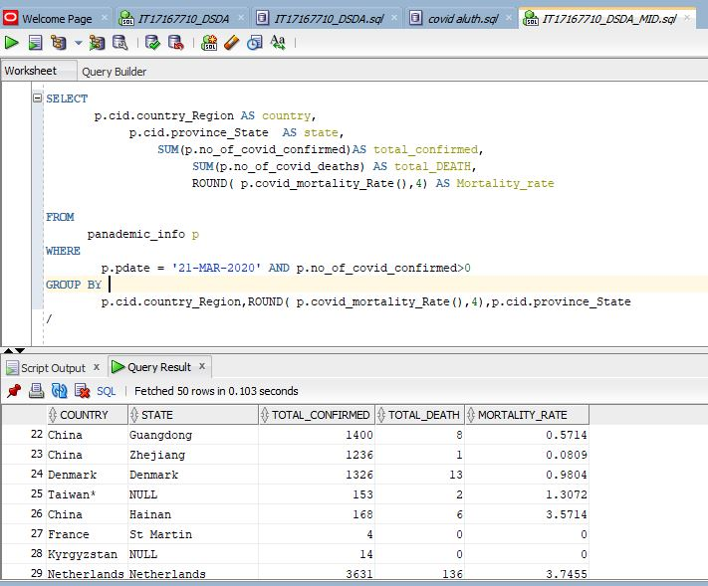

**Mortality Rate (**The case fatality rate) = (deaths count **/** **Confirmed count) *100**

= ( 1 / 1236 ) *100

= 0.0008090 *100

= **0.08090%**

In China Zhejiang state, about 0.08090%of reported COVID-19 cases have died

1. **Coronavirus COVID-19 Recovered / Discharged- (country and state wise)**

**SELECT**

p**.**cid**.**country_Region **AS** country**,**

p**.**cid**.**province_State **AS** **state,**

**SUM(**p**.**no_of_covid_confirmed**)AS** total_confirmed**,**

**SUM(**p**.**no_of_covid_recovered**)** **AS** total_recovered**,**

**ROUND(** p**.**covid_recover_Rate**(),**4**)** **AS** Recovery_rate

**FROM**

panademic_info p

**WHERE**

p**.**pdate **=** '21-MAR-2020' **AND** p**.**no_of_covid_confirmed**>**0

**GROUP** **BY**

p**.**cid**.**country_Region**,ROUND(** p**.**covid_recover_Rate**(),**4**),**p**.**cid**.**province_State

**/**

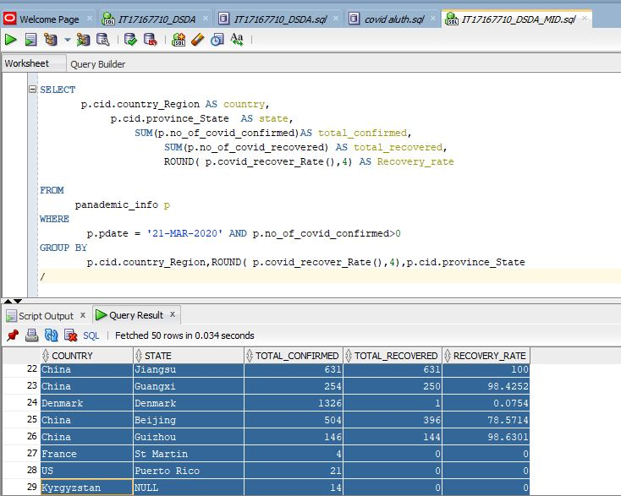

**Recovered cases Rate = (number of Recovered Cases /** **Confirmed count) *100**

**Recovery cases Rate = (number of Recovered Cases /** **Confirmed count) *100**  
 = ( 396 / 504 ) * 100

**=** 0.78571 *100

**=** 78.5714 %

In China Beijing state, about 78.5714 % of reported COVID-19 cases have Recovered

**Coronavirus COVID-19 CLOSED Cases - (country and state wise)**

**SELECT**

p**.**cid**.**country_Region **AS** country**,**

p**.**cid**.**province_State **AS** **state,**

**SUM(**p**.**no_of_covid_confirmed**)AS** total_confirmed**,**

**SUM(**p**.**numberOf_CLOSED_CASES**())** **AS** total_Closed_Cases**,**

**ROUND(SUM(**p**.**numberOf_CLOSED_CASES**())/SUM(**p**.**no_of_covid_confirmed**)\***100**,**4**)** **AS** CLOSED_CASES_RATE

**FROM**

panademic_info p

**WHERE**

p**.**pdate **=** '21-MAR-2020' **AND** p**.**no_of_covid_confirmed**>**0

**GROUP** **BY**

p**.**cid**.**country_Region**,**p**.**cid**.**province_State

**/**

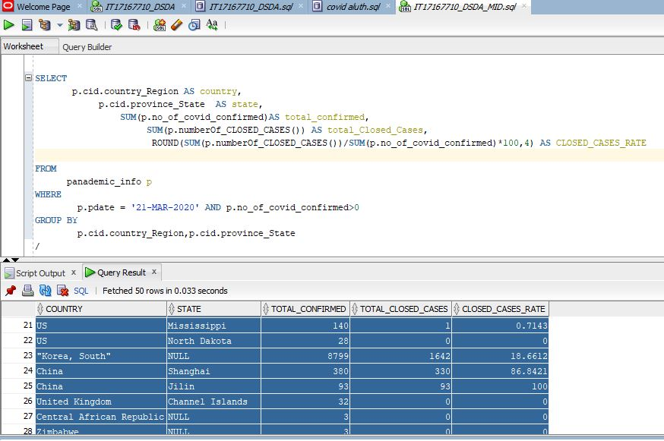

**Closed Cases Rate = ( number of Closed Cases / Confirmed count ) *100**

= ( 330 / 380 ) * 100

= 0.868421*100 = **86.8421%**

In China Shanghai state, about ***86.8421%*** of reported COVID-19 cases have an outcome (which means either died or Discharged).

**Coronavirus COVID-19 Active Cases - (country and state wise)**

**SELECT**

p**.**cid**.**country_Region **AS** country**,**

p**.**cid**.**province_State **AS** **state,**

**SUM(**p**.**no_of_covid_confirmed**)AS** total_confirmed**,**

**SUM(**p**.**numberOf_Active_Cases **())** **AS** total_Active_Cases**,**

**ROUND(** p**.**Active_Cases_Rate**(),**4**)** **AS** ACTIVE_CASES_RATE

**FROM**

panademic_info p

**WHERE**

p**.**pdate **=** '21-MAR-2020' **AND** p**.**no_of_covid_confirmed**>**0

**GROUP** **BY**

p**.**cid**.**country_Region**,ROUND(** p**.**Active_Cases_Rate**(),**4**),**p**.**cid**.**province_State

**/**

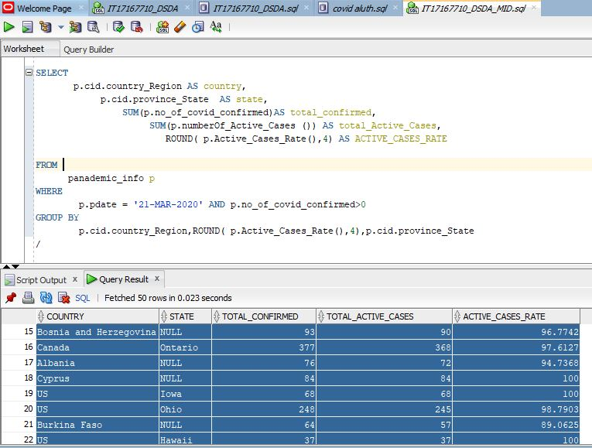

* In Canada Ontario, about ***97.61217%*** of reported COVID-19 cases are Currently Infected.
* In US, Iowa state, about ***100%*** of reported COVID-19 cases are Currently Infected.

**Coronavirus COVID-19 Cases - (Coronavirus Cases in China vs Outside of China)**

1. **(Coronavirus Cases in China)**

This report represents the total number of deaths, Active cases, recovery cases and Confirmed cases of coved 19 in china on the date of 21th March 2020.

**SELECT** p**.**pdate**,**

**SUM(**p**.**no_of_covid_confirmed**)AS** confirmed **,**

**sum(**p**.**no_of_covid_deaths**)** **AS** deaths **,**

**ROUND(SUM(**p**.**no_of_covid_deaths**)/SUM(**p**.**no_of_covid_confirmed**)\***100**,**4**)** **AS** motality_Rate**,**

**SUM(**p**.**no_of_covid_recovered**)** **AS** recovered**,**

**ROUND(SUM(**p**.**no_of_covid_recovered**)/SUM(**p**.**no_of_covid_confirmed**)\***100**,**4**)** **AS** Recovery_Rate**,**

**SUM(**p**.**numberOf_Active_Cases**())** **AS** Active_cases**,**

**ROUND((sum(**p**.**numberOf_Active_Cases**())/sum(**p**.**no_of_covid_confirmed**))\***100**,**3**)** **AS** Active_Rate**,**

**SUM(**p**.** numberOf_CLOSED_CASES**())** **AS** closed_cases**,**

**ROUND(SUM(**p**.**numberOf_CLOSED_CASES**())/SUM(**p**.**no_of_covid_confirmed**)\***100**,**4**)** **AS** CLOSED_CASES_RATE

**FROM**

panademic_info p

**WHERE**

p**.**pdate**=**'21-MAR-2020' **AND** p**.**no_of_covid_confirmed**>**0 **AND** p**.**cid**.**country_Region **=**'China'

**GROUP** **by**

p**.**pdate**;**

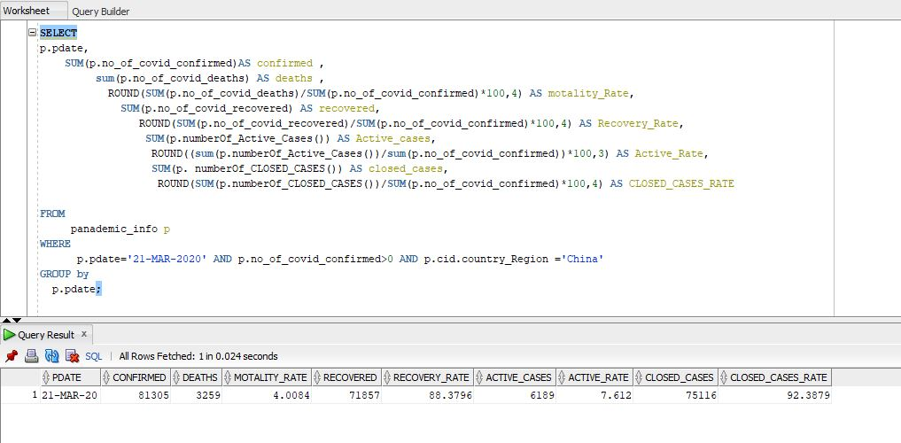

* 81305 have confirmed, 3259 people have died with a rate of 4.0084%, 71857 recovered with a rate of 88.3796%, and 6189 people are currently infected with a rate of 7.612 %so far from the coronavirus COVID-19 outbreak as of 21-MAR- 2020 in china

1. **(Coronavirus Cases outside of China)**

This report represents Total Coronavirus confirmed Cases, Active Cases, Deaths cases, recovery cases and closed cases in outside of China

**SELECT** p**.**pdate**,**

**SUM(**p**.**no_of_covid_confirmed**)AS** confirmed **,**

**sum(**p**.**no_of_covid_deaths**)** **AS** deaths **,**

**ROUND(SUM(**p**.**no_of_covid_deaths**)/SUM(**p**.**no_of_covid_confirmed**)\***100**,**4**)** **AS** motality_Rate**,**

**SUM(**p**.**no_of_covid_recovered**)** **AS** recovered**,**

**ROUND(SUM(**p**.**no_of_covid_recovered**)/SUM(**p**.**no_of_covid_confirmed**)\***100**,**4**)** **AS** Recovery_Rate**,**

**SUM(**p**.**numberOf_Active_Cases**())** **AS** Active_cases**,**

**ROUND((sum(**p**.**numberOf_Active_Cases**())/sum(**p**.**no_of_covid_confirmed**))\***100**,**3**)** **AS** Active_Rate**,**

**SUM(**p**.** numberOf_CLOSED_CASES**())** **AS** closed_cases**,**

**ROUND (SUM(**p**.** numberOf_CLOSED_CASES**())/SUM(**p**.**no_of_covid_confirmed**)\***100**,**4**)**

**AS** CLOSED_CASES_RATE

**FROM** panademic_info p

**WHERE** p**.**pdate**=**'21-MAR-2020' **AND** p**.**no_of_covid_confirmed**>**0 **AND** **NOT** p**.**cid**.**country_Region **=**'China'

**GROUP** **by** p**.**pdate**;**

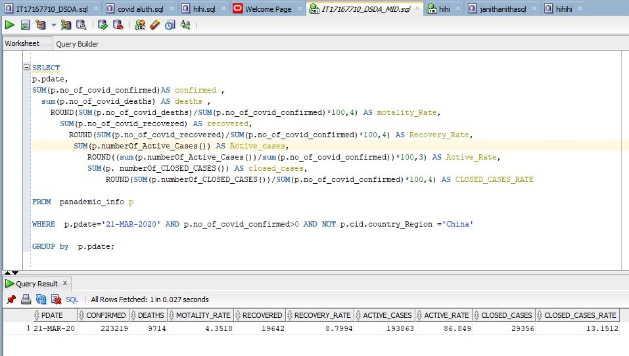

* 223219 have confirmed, 9714 people have died with a rate of 4.3518%, 19642 recovered with a rate of 8.7994%, and 193863 people are currently infected with a rate of 86.849 %so far from the coronavirus COVID-19 outbreak as of 21-MAR- 2020 in in outside of China.

**Coronavirus COVID-19 Cases – Comparisons**

This report contains about full detailed report of the countries which exceeded 10000 patients of **COVID-19**. And each state of them where death toll is reported more than the recovery toll on 21th March,2020

**SELECT** p**.**cid**.**country_Region **AS** country **,**

p**.**cid**.**province_State **AS** **State** **,**

**SUM(**p**.**no_of_covid_confirmed**)AS** confirmed **,**

**sum(**p**.**no_of_covid_deaths**)** **AS** deaths **,**

**ROUND(SUM(**p**.**covid_mortality_Rate**()),**3**)** **AS** motality_Rate**,**

**SUM(**p**.**no_of_covid_recovered**)** **AS** recovered**,**

**ROUND(SUM(**p**.**covid_recover_Rate**()),**3**)** **AS** Recovery_Rate**,**

**SUM(**p**.**numberOf_Active_Cases**())** **AS** Active_cases**,**

**ROUND(SUM(**p**.**Active_Cases_Rate**()),**3**)** **AS** Active_Rate**,**

**SUM(**p**.** numberOf_CLOSED_CASES**())** **AS** closed_cases**,**

**ROUND(SUM(**p**.**numberOf_CLOSED_CASES**())/SUM(**p**.**no_of_covid_confirmed**)\***100**,**4**)** **AS** CLOSED_CASES_RATE

**FROM** panademic_info p

**WHERE** p**.**pdate **=** '21-MAR-2020' **AND**

p**.**no_of_covid_confirmed **IN**

**(SELECT** **sum(**p**.**no_of_covid_confirmed**)**

**from** panademic_info p

**group** **by** p**.**no_of_covid_confirmed

**HAVING** **sum(**p**.**no_of_covid_confirmed**)>**10000**)**

**GROUP** **BY** p**.**cid**.**country_Region**,**p**.**cid**.**province_State**,**p**.**no_of_covid_confirmed

**HAVING** **SUM(**p**.**no_of_covid_Recovered**)** **<** **SUM(**p**.**no_of_covid_deaths**)**

**/**

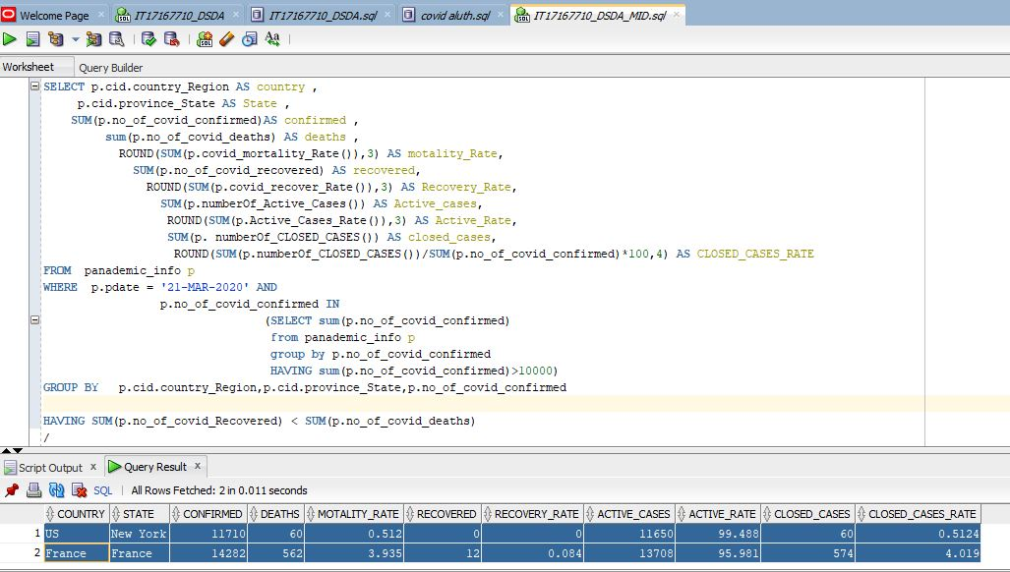

#### 8)

Here is the 2 SEQUENCE and the 2 Triggers that is used to create an incrementing numeric key, and to automatically populates the primary keys for 2 tables

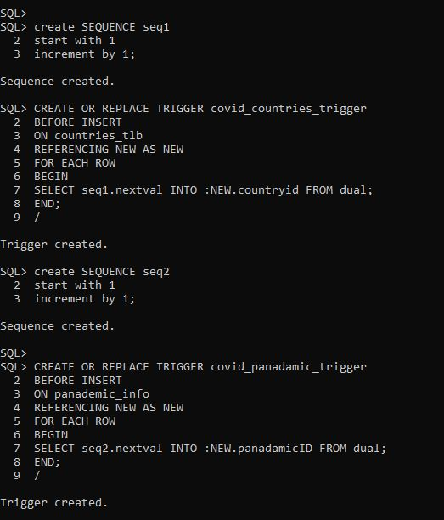

after the CSV files load into the Oracle tables. I wrote simple query to verify whether the

data loading done correctly

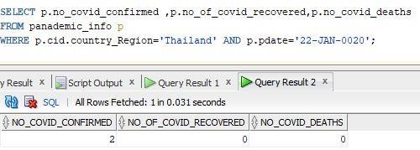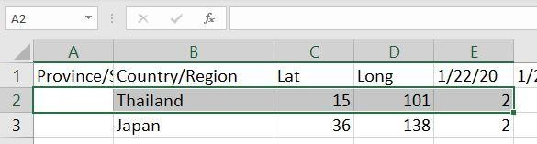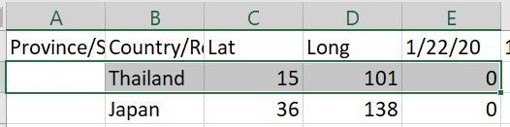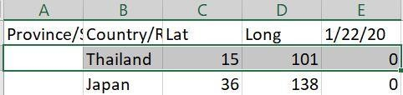

covid_Recovered.CSV'

covid_Confirmed.CSV'

covid_

D

eath

.CSV'

**References**

<https://alloraclesql.blogspot.com/2017/03/csv-file-loader-in-oracle-using-plsql.html> - load CSV

<https://stackoverflow.com/questions/11296361/how-to-create-id-with-auto-increment-on-oracle> -

<https://www.tekstream.com/resource-center/ora-01843-not-a-valid-month/> - Date format

<http://nimishgarg.blogspot.com/2013/04/load-csv-file-in-oracle-using-plsql.html> - load CSV